

JTSS-3200X PANEL SAW
JTSS-3200X-T...10000047XT…3~400V, 50Hz

PARTS LIST

JPW (Tool) AG
Tämperlistrasse 5 CH-8117 Fällanden Switzerland
Phone +41 44 806 47 48
Fax +41 44 806 47 58

www.jettools.com

P-10000047XT 2014-04
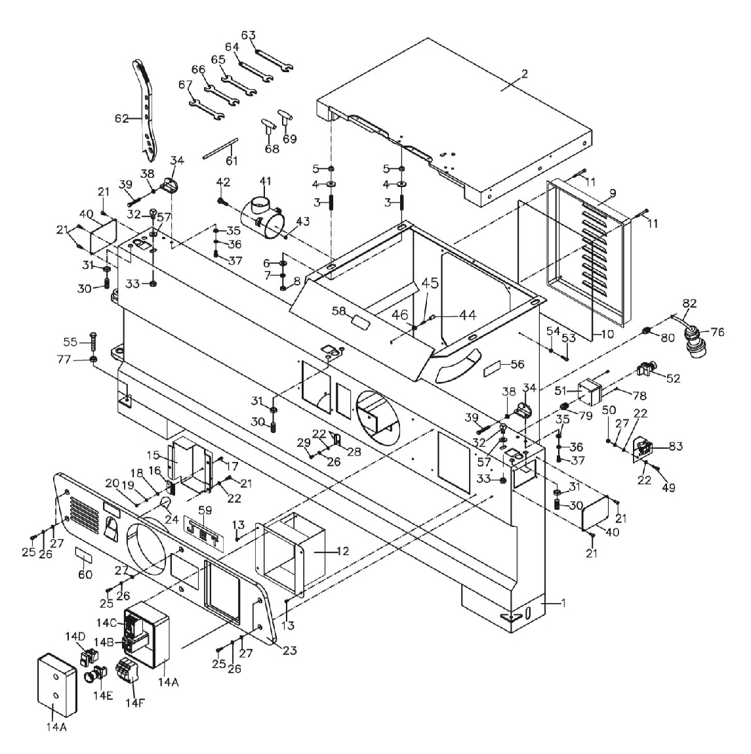

Cabinet and Table assembly
Parts List for The JTSS-3200X Panel Saw

2

Table and Cabinet Assembly

Index Part
No. No. Description Size Qty.
1 JTSS3200X-101 Cabinet 1
2 JTSS3200X-102 Main Table 1
3 JTSS3200X-103 Set Screw M10x70 4
4 TS-1550071 Flat Washer M10 4
5 TS-2342101 Nylon Nut M10-1.5P 4
6 TS-1550071 Flat Washer M10 4
7 TS-2361101 Lock Washer M10 4
8 TS-2311101 Nylon Nut M10-1.5P 4
9 JTSS3000-115 Motor Cover 1
10 JTSS3200X-110 Foam Strip 1
11 TS-1503131 Socket Head Cap Screw M6x60 4
12 JTSS3200X-112 Switch Box 1
13 TS-2246102 Socket Head Button Screw M6x10 4
14 JTSS3200X-114AE Magnetic Switch Assembly (item 14 - 14G) 5.5Hp, 400V, 3Ph 1
14A JTSS3200X-114A Control Box 1
14B JTSS3200X-114ORAE Overload Relay 5.5Hp, 400V, 3Ph 1
14C JTSS3200X-114CSAE Contactor Switch 400V, 3Ph 1
14D JTSS3200X-114D ON / OFF Switch with LED light 1
14E JTSS3200X-114E Emergency Switch 1
14F JTSS3200X-114F Fuse Seat Assembly 1
14G JTSS3200X-114G Fuse (not Shown) 12A 3
14H JTSS3200X-114H LED Light (not Shown) 1
15 JTSS3000-131 Scale Dust Cover 1
16 JTSS3200-166 Brush 1
17 TS-1533062 Pan Head Screw M5x20 1
18 TS-1550031 Flat Washer M5 1
19 TS-2361051 Lock Washer M5 1
20 TS-1540031 Hex Nut M5 1
21 TS-2246122 Socket Hand Button Screw M6x12 11
22 TS-1550041 Flat Washer M6 8
23 JTSS3200X-123 Cover 1
24 JTSS3000-111 Scale Plate 1
25 TS-1503041 Socket Head Cap Screw M6x14 6
26 TS-2361061 Lock Washer M6 7
27 TS-1550041 Flat Washer M6 8
28 JTSS3000-134 Pointer 1
29 TS-1534032 Pan Head Screw M6x10 1
30 JTSS3000-121N Socket Set Screw M14x35 6
31 JTSS3000-122 Hex Nut M14 6
32 JTSS3000-123 Positioning Screw 2
33 TS-2342121 Nylon Nut M12 2
34 JTSS3200X-134 Stop Bracket 2
35 TS-0680032 Flat Washer M8 4
36 TS-0720081 Lock Washer M8 4
37 TS-1490021 Hex Cap Bolt M8x16 4
38 TS-2311081 Hex Nut M8 2
39 TS-1490091 Hex Cap Bolt M8x50 2
40 JTSS3000-113 Adjustment Bolt Cover 2
41 JTSS3200X-141 Dust Chute 1
42 TS-0050021 Hex Cap Bolt 1/4”-20x5/8” 3
43 TS-0640071 Nylon Nut 1/4”-20 3
44 JTSS3200-165 Stop Block 1
45 TS-1524041 Set Screw M8x16 1

3

Index Part
No. No. Description Size Qty.

46 TS-1541031 Nylon Nut M8 1
49 TS-1503051 Socket Head Cap Screw M6x20 2
50 TS-1541021 Nylon Nut M6 2
51 JTSS3200X-151 Switch Box 1
52 JTSS3200X-152 Emergency Switch
53 TS-1503061 Socket Head Cap Screw M6x25 1
54 TS-1540041 Hex Nut M6 1
55 TS-1492061 Hex Cap Bolt M12x60 4
56 JTSS3200X-156 Blade Raise Label 1
57 TS-2360121 Flat Washer M12 2
58 JTSS3200X-158 Label 1
59 JET-138 JET nameplate 1
60 JTSS3000-133 Blade Angle Label 1
61 JTSS1500-151 Arbor index pin ø 8mm 1
62 JTSS1500-150 Push Stick 1
63 JTSS1500-152 Open End Wrench 13mm 1
64 JTSS1500-153 Open End Wrench 19mm 1
65 JTSS1500-154 Open End Wrench 10-12mm 1
66 JTSS1500-155 Open End Wrench 14-17mm 1
67 JTSS1500-156 Open End Wrench 22-24mm 1
68 JTSS1500-157 T-style Allen Wrench 4mm 1
69 JTSS3200X-169 T-style Allen Wrench 5mm 1
70 JTSS3200X-170 T-style Allen Wrench (not shown) 6mm 1
71 JTSS3200X-171 L style Allen Wrench (not shown) 2mm 1
72 TS-152704 L style Allen Wrench (not shown) 3mm 1
73 TS-152705 L style Allen Wrench (not shown) 4mm 1
74 TS-152706 L style Allen Wrench (not shown) 5mm 1
75 TS-152707 L style Allen Wrench (not shown) 6mm 1
76 JTSS3000-129 Power Plug 3Ph 1
77 TS-2311121 Hex Nut M12 4
78 JTSS3200X-178 Pan Head Screw M4X15 2
79 JML-70E Strain Relief PG9 2
80 JWL1642-196E Strain Relief PG13.5 3
82 JTSS3200X-182 Power Cord 1
83 JTSS2500-180 Safety Guard 1

4
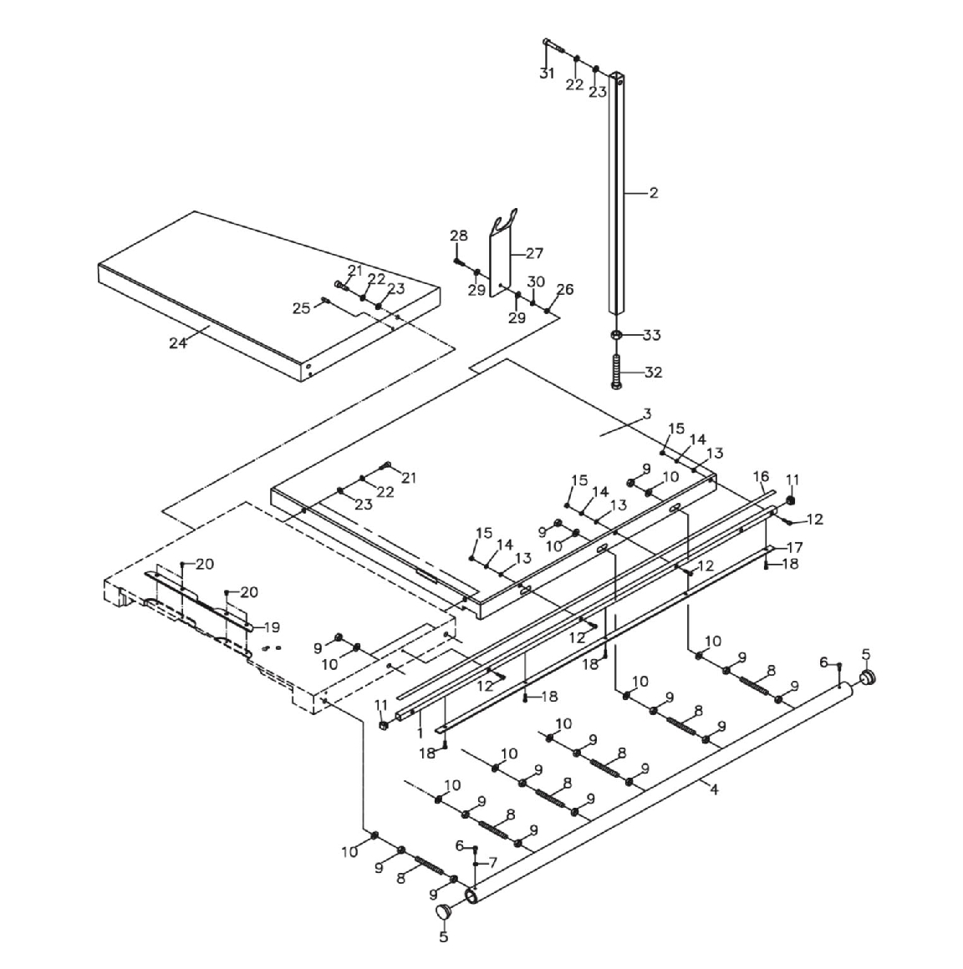

Parts List For The JTSS-3200X Panel Saw
Table Extension Assembly

5

Table Extension Assembly
Index Part
No. No. Description Size Qty.

1 JTSS3000-547 Gear Base 1
2 JTSS3000-557 Extension Table Support 1
3 JTSS3000-544 Extension Table 1
4 JTSS3000-530 Rail 1
5 JTSS1500-137 Rubber Plug 2
6 TS-1503031 Socket Head Cap Screw M6x12 2
7 JTSS1500-142 Eccentric Washer 1
8 JTSS1500-127 Screw M12x100 6
9 TS-2311121 Hex Nut M12 18
10 TS-2360121 Flat Washer M12 12
11 JTSS1500-115 Gear Base Cover 2
12 TS-1503051 Socket Head Cap Screw M6x20 8
13 TS-1550041 Flat Washer M6 10
14 TS-2361061 Lock Washer M6 10
15 TS-1540041 Hex Nut M6 5
16 JTSS3000-539 Scale 1
17 JTSS3000-537 Gear Strip 1
18 TS-1502011 Socket Head Cap Screw M5x8 5
19 JTSS3200X-219 Table Insert 1
20 JTSS1500-134 Flat Head Screw M5x10 4
21 TS-1505031 Socket Head Cap Screw M10x25 4
22 TS-2361101 Lock Washer M10 5
23 TS-1550071 Flat Washer M10 5
24 JTSS1500 Extension Table 1
25 TS-1524061 Socket Set Screw M8x25 2
26 TS-1541031 Nylon Nut M8 1
27 JTSS1500-110 Hose Support 1
28 TS-1504051 Socket Head Cap Screw M8x25 1
29 TS-1550061 Flat Washer M8 2
30 TS-2361081 Lock Washer M8 1
31 TS-1491101 Hex Cap Bolt M10x60 1
32 TS-149B16 Hex Cap Bolt M16X100 1
33 TS-154010 Hex Nut M16 1

6
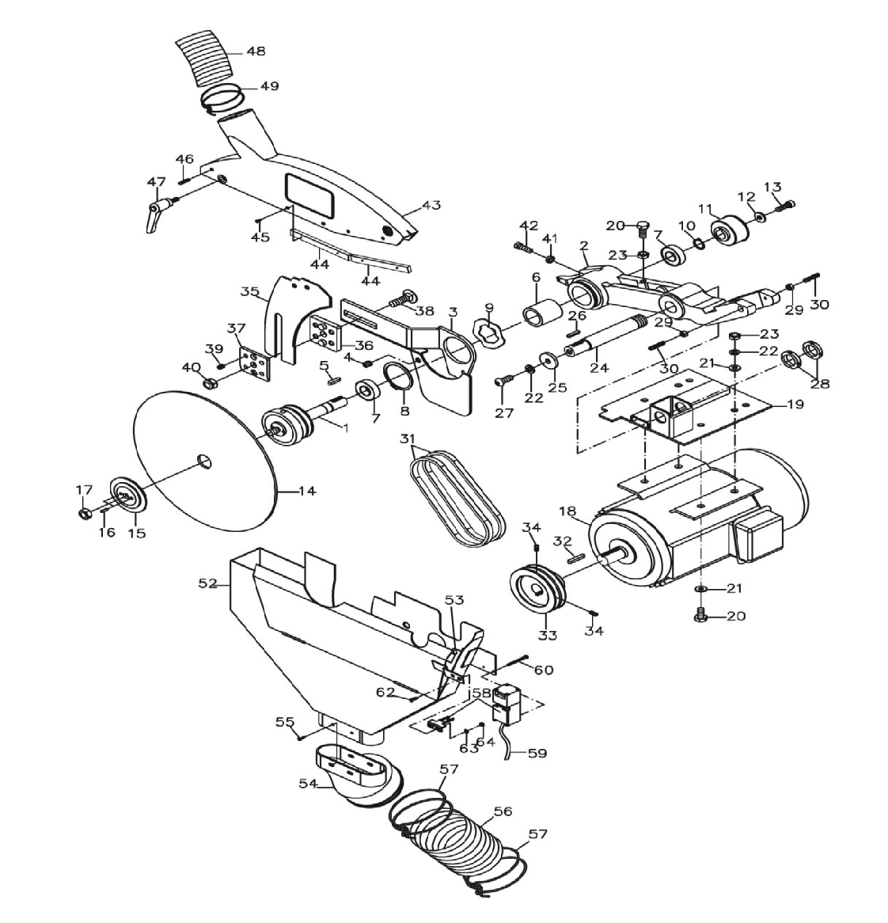

Parts List For The JTSS-3200X Panel Saw
Motor and Blade Guard Assembly

7

Motor and Blade Guard Assembly

Index Part
No. No. Description Size Qty.
1 JTSS1500-633 Blade Arbor 1
2 JTSS3200X-602 Rotate Part 1
3 JTSS1500-620 Knife Base 1
4 JTSS3200X-604 Nylon Screw M12-1.75x12 1
5 JTSS1500-322 Key……………………… 6x6x20 1
6 JTSS3200X-606 Spacer 1
7 VV-6004ZZ Ball Bearing 6004VV 2
8 JTSS3200X-608 S-Ring S60 1
9 JTSS3200X-609 Wave Washer 1
10 JTSS3200X-610 S-Ring S20 1
11 JTSS1500-321 Pulley 1
12 TS-1550061 Flat Washer M8 1
13 TS-1504041 Socket Head Cap Screw………………………. M8x25 1
14 JTSS1500-634 Blade 1
15 JTSS1500-636 Flange 1
16 JTSS1500-635 Spring Pin ψ4x12 2
17 JTSS1500-637 Hex Nut M12x1.75P(LT) 1
18 JTSS3200X-618AE Motor 5.5Hp, 3Ph, 400V 1
............ JTSS3200X-MBA Motor Break Assembly (not shown) 1
............ JTSS3200X-BRMB Bridge Rectifier for Motor Break (not shown) 1
19 JTSS1500-614 Motor Plate 1
20 TS-1491041 Hex Cap Bolt M10x30 5
21 TS-1550071 Flat Washer M10 8
22 TS-2361101 Lock Washer M10 5
23 TS-1540071 Hex Nut M10 5
24 JTSS3200X-624 Shaft 1
25 TS-1550071 Flat Washer M10 1
26 JTSS3200X-626 Key 5x5x25 1
27 TS-2249252 Socket Head Button Screw M10x25 1
28 JTSS1500-613 Bearing Nut M25-1.5P 2
29 TS-1540041 Hex Nut M6 2
30 JTSS3200X-630 Set Screw M6x30 2
31 JTSS1500-622 Belt 3VX-265 2
32 JTSS1500-603 Key 6x6x30 1
33 JTSS1500-604 Pulley 1
34 TS-2276081 Socket Set Screw With Nylon M6x8 4
35 JTSS3200X-635 Riving Knife 1
36 JTSS1500-629 Riving Knife Cover 1
37 JTSS1500-630 Cover Fix Block 1
38 JTSS1500-619 Carriage Bolt M12x35 1
39 TS-1524011 Socket Set Screw M8x8 4
40 JTSS1500-632 Lock Nut M12 1
41 TS-2311081 Hex Nut M8 1
42 TS-1524061 Set Screw M8x25 1
............ JTSS3200X-BGA Blade Guard Assembly (Item 43 - 46) 1
43 JTSS3200X-643 Saw Blade Guard 1
44 JTSS3200X-644 Board……………………… 4
45 JTSS3200X-645 Screw M3x10 8
46 JTSS1500-624 Spring Pin ψ6x30 1
47 JTSS3200X-647 Lock Handle 1
48 JTSS1500-648 Dust tube dia. 60mm 1
49 JTSS3200X-649 Clamping 60mm 1
52 JTSS3200X-652 Dust Cover 1

8

Motor and Blade Guard Assembly (Part 6)

53 JTSS1500-647 Magnet 1
54 JTSS3200X-654 Dust Hose Adaptor M5x10 4
55 JTSS3200X-655 Machine Screw M5x10 4
56 JTSS1500-649 Dust tube dia. 100mm 1
57 JTSS3200X-657 Hose Clamping 2
58 JTSS1500-639 Limit Switch 1
59 JTSS3200X-659 Limiter Switch Cord 1
60 JTSS1500-640 Flat Head Screw M4x40 2
62 TS-1532032 Pan Head Screw M4x10 2
63 TS-1550021 Flat Washer M4 2
64 TS-1540021 Hex Nut M4 2
65 JTSS3200X-665 Motor Cord 1

9
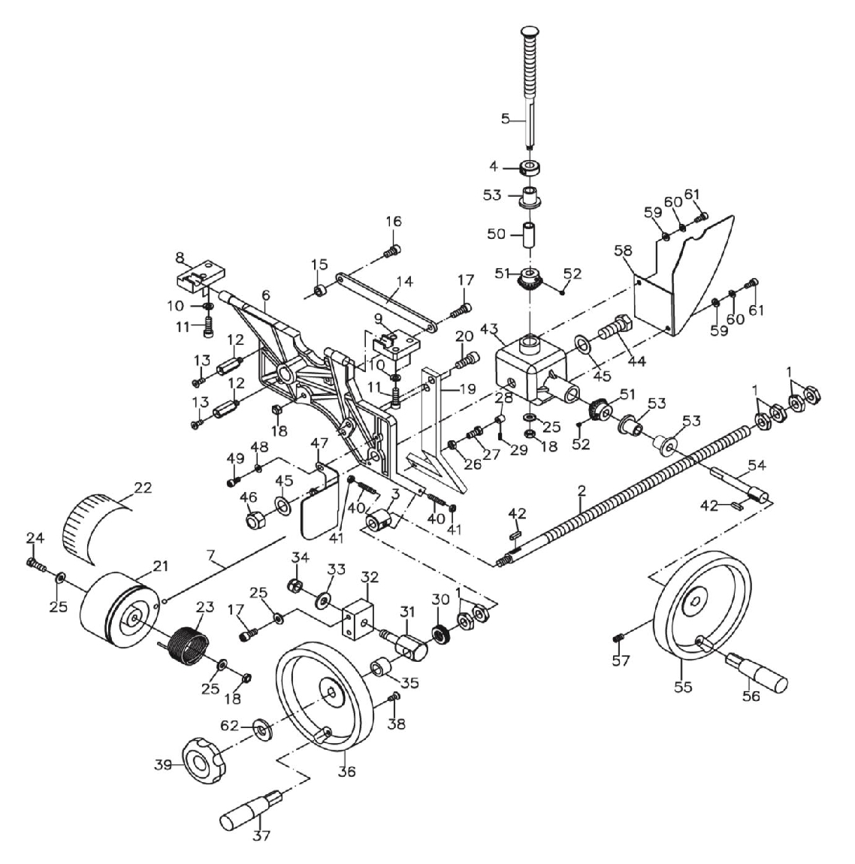

Parts List For The JTSS-3200X Panel Saw
Turning Assembly

10

Turning Assembly
Index Part
No. No. Description Size Qty.

1 JTSS3200X-401 Hex Nut 6
2 JTSS3200X-402 Lead Screw 1
3 JTSS3200X-403 Square Nut 1
4 JTSS3200X-404 Square Nut 1
5 JTSS3200X-405 Worm 1
6 JTSS3200X-406 Turning 1
7 JTSS1500-443 Steel Rope 1
8 JTSS3200X-408 Rotate Part Fix 1
9 JTSS3200X-409 Rotate Part Fix 1
10 TS-2361081 Lock Washer M8 5
11 TS-1504041 Socket Head Cap Screw M8x20 5
12 JTSS3200X-412 Cover Sport 3
13 TS-1515011 Socket Head Flat Screw M8x15 3
14 JTSS1500-426 Crank 1
15 JTSS1500-427 Pulley Pad
16 TS-1504031 Socket Head Cap Screw M8x16 1
17 TS-1504061 Socket Head Cap Screw M8x30 3
18 TS-1541031 Nylon Nut M8 3
19 JTSS1500-430 Gather Shaft 1
20 TS-1505031 Socket Head Cap Screw M10x25 2
21 JTSS1500-448 Steel Rope Wheel 1
22 JTSS1500-450 Scale Label 1
23 JTSS1500-447 Spring 1
24 JTSS1500-449 Hex Cap Bolt M8x75 1
25 TS-1550061 Flat Washer M8 4
26 TS-2311081 Hex Nut M8 1
27 JTSS1500-429 Gather Bolt 1
28 JTSS1500-442 Steel Rope Jacket 1
29 TS-1501031 Socket Set Screw M4x10 1
30 JTSS3200X-430 Thrust Bearing 1
31 JTSS3200X-431 Fix Arbor 1
32 JTSS1500-451 Fix Arbor Nut 1
33 TS-2360121 Flat Washer M12 1
34 TS-2342121 Lock Nut M12 3
35 JTSS3200X-435 Bushing 1
36 JTSS3200X-436 Hand Wheel 1
37 JTSS3200X-437 Handle (Includes #38) 1
38 TS-1514011 Socket Head Flat Screw M6x12 1
39 JTSS1500-401 Knob Nut M10x1.5 1
40 JTSS3200X-440 Set Screw M6x30 2
41 TS-1541021 Hex Nut M6 2
42 JTSS3200X-442 Key 5x5x20 2
43 JTSS1500-416 Gear Box 1
44 JTSS1500-417 Hex Cap Bolt M16x2.0Px40 1
45 JTSS3200X-445 Fiber Washer 2
46 JTSS1500-423 Lock Nut M16 1
47 JTSS1500-439 Cover 1
48 TS-1550031 Flat Washer M5 2
49 TS-1502021 Socket Head Cap Screw M5x10 2
50 JTSS3200X-450 Bushing 1
51 JTSS3200X-451 Gear 2
52 TS-1523011 Socket Set Screw M6x6 2

11

Index Part
No. No. Description Size Qty.

53 JTSS1500-418 Copper Sleeve 3
54 JTSS1500-412 Handle Wheel Arbor 1
55 JTSS3200X-455 Handwheel 1
56 JTSS3200X-456 Handle 1
57 TS-1524031 Set Screw M8x12 1
58 JTSS1500-421 Upper Cover 1
59 TS-1550041 Flat Washer M6 2
60 TS-2361061 Spring Washer M6 2
61 TS-1503041 Socket Head Cap Screw M6x14 2
62 TS-1550071 Flat Washer M10 1

12
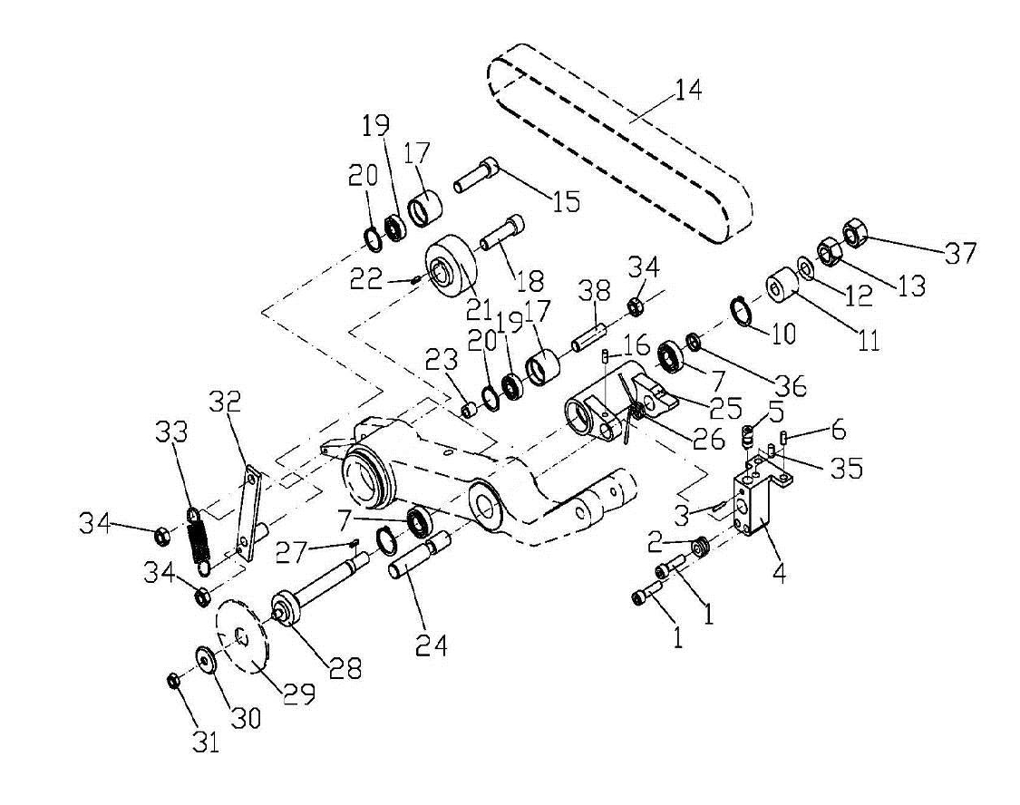
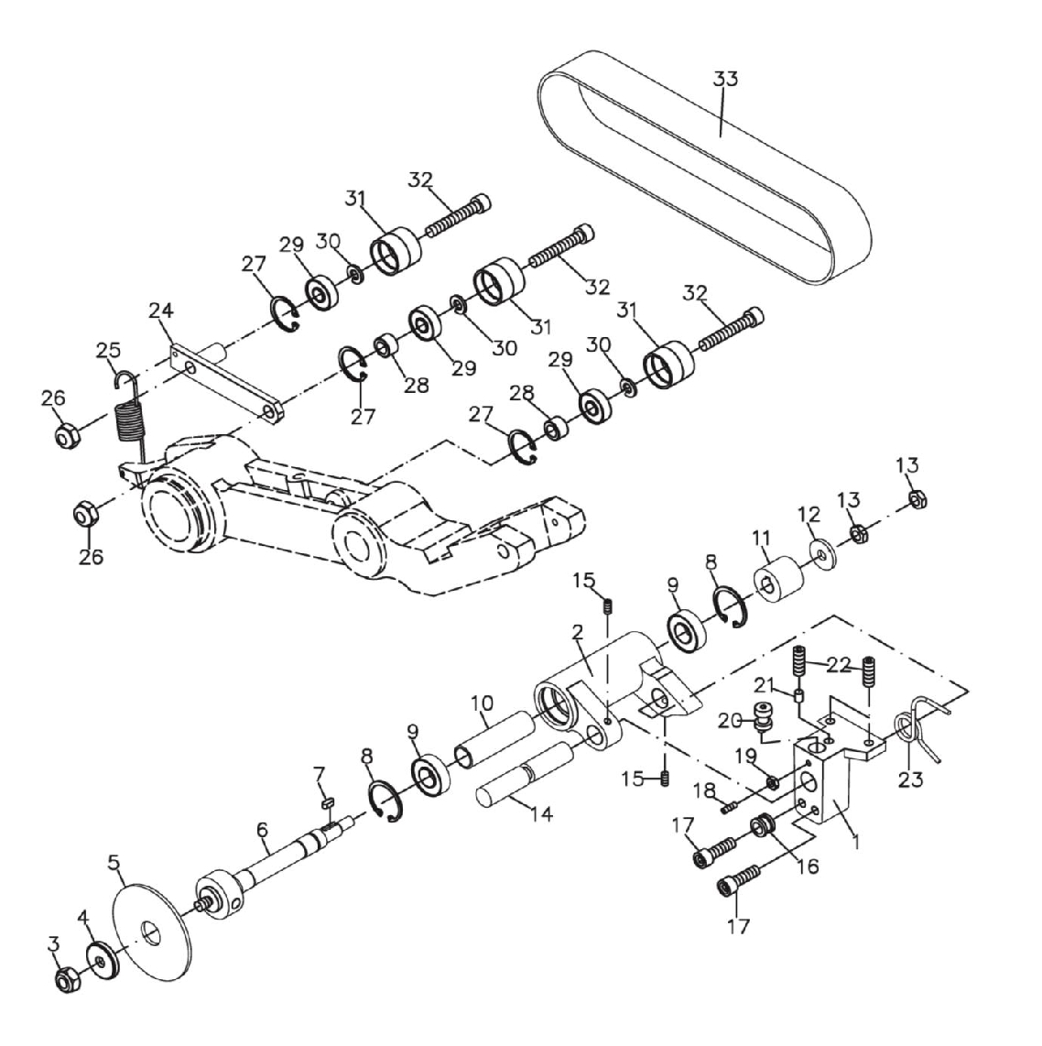

Parts List For The JTSS-3200X Panel Saw
Scoring Assembly

13

Scoring Assembly
Index Part
No. No. Description Size Qty.
1 JTSS1500-304 Link Shaft Fix Base 1
2 JTSS3200X-325 Blade Link Shaft 1
3 JTSS1500-331 Nylon Nut M8x1.25P 1
4 JTSS1500-330 Flange 1
5 JTSS1500-329 Scoring Blade ø 80/ ø 20mm 1
6 JTSS1500-328E Blade Arbor 1
7 JTSS1500-327 Key 4x4x10 1
8 JTSS1500-310 Ring RTW-32 2
9 BB-6002VV Ball Bearing 6002VV 2
10 JTSS3200X-410 Bushing 1
11 JTSS1500-311 Blade Pulley 1
12 TS-1550061 Flat Washer M8 1
13 JTSS1500-313 Hex Nut M8x1.25P (LT) 2
14 JTSS1500-324 Blade Link Shaft Arbor 1
15 TS-1523031 Set Screw M6x10 2
16 JTSS1500-302 Sleeve 1
17 TS-1504071 Socket Head Cap Screw M8x35 2
18 TS-1522031 Socket Set Screw M5x10 1
19 TS-1540031 Hex Nut M5 1
20 JTSS1500-305 Adjustment Screw 1
21 JTSS1500-335 Copper Bar 1
22 TS-1524061 Socket Set Screw M8x25 3
23 JTSS1500-326 Spring 1
24 JTSS1500-332 Pulley Support 1
25 JTSS1500-333 Spring 1
26 JTSS1500-334 Nylon Nut M10x1.5P 2
27 JTSS1500-320 Ring RTW-26 3
28 JTSS1500-323 Pulley Pad 4
29 BB6000 Ball Bearing 6000 3
30 TS-2361081 Spring Washer M8 3
31 JTSS1500-317 Pulley 3
32 TS-1504051 Socket Head Cap Screw M8x25 2
33 JTSS1500-314N Flat Belt 1
............ JTSS3200X-CSA Complete Scoring Assembly (Index # 1 - 24) 1

14
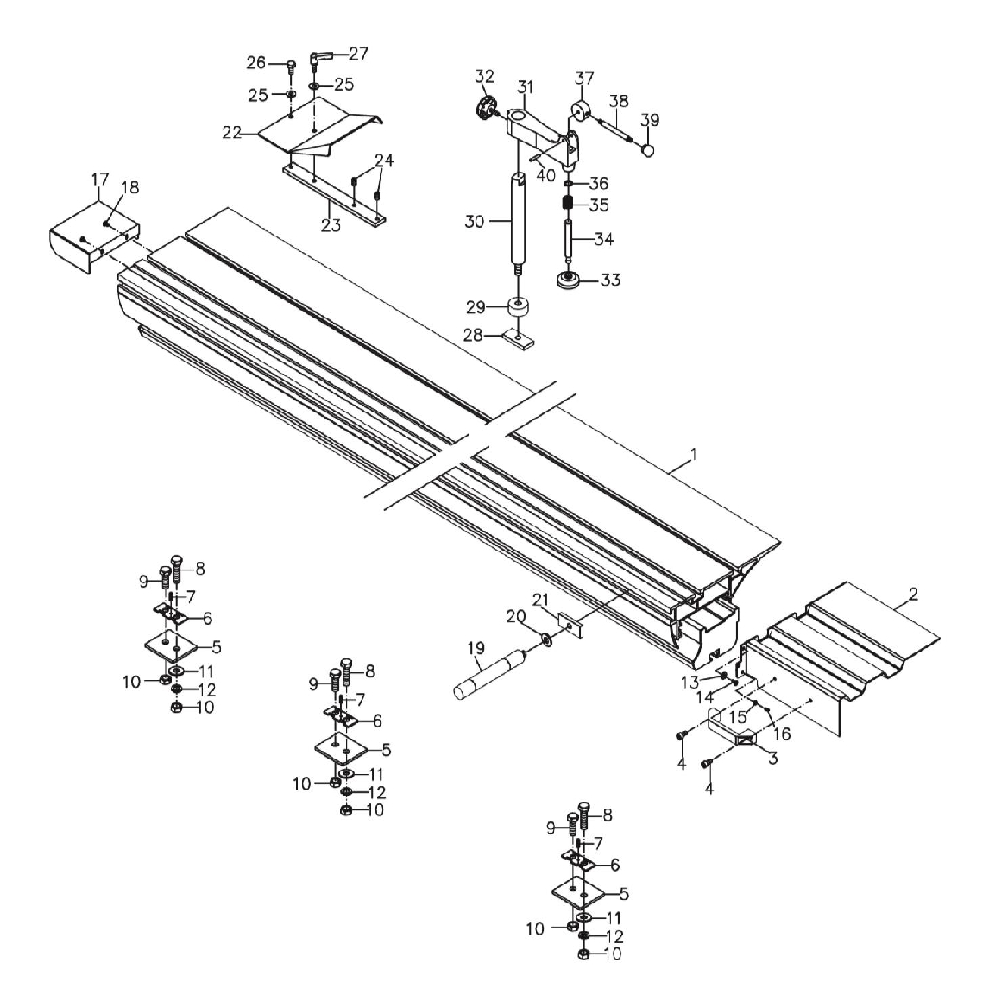

Parts List For The JTSS-3200X Panel Saw
Sliding Table Assembly

15

Sliding Table Assembly

Index Part
No. No. Description Size Qty.
1 JTSS3200X-701 Sliding Table Assembly 1
2 JTSS3200X-702 Sliding Table Handle 1
3 JTSS3000X-703 Work Handle 1
4 TS-1504031 Socket Head Cap Screw M8x16 2
5 JTSS3000-427 Adjustment Plate 3
6 JTSS3200X-706 Holding Bracket 3
7 TS-1523061 Set Screw M6x20 3
8 JTSS3000-428 Hex Cap Bolt M14x40 3
9 JTSS3000-429 Hex Cap Bolt M14x30 3
10 TS-2310142 Hex Nut M14 12
11 TS-155009 Flat Washer M14 3
12 TS-2361141 Lock Washer M14 3
13 TS-2361061 Lock Washer M6 4
14 TS-2246162 Socket Head Button Screw M6x16 4
15 TS-1540031 Hex Nut M5 2
16 TS-1522031 Set Screw M5x10 2
17 JTSS3200X-717 Safety Guide 1
18 JTSS3200X-718 Machine Screw M5x8 2
19 JTSS3000-411 Push Handle 1
20 JTSS3000-448 Plastic Washer 1
21 JTSS3200X-721 Push Board Block 2
22 JTSS3000-444 Stop Board 1
23 JTSS3000-443 Stop Board Block 1
24 JTSS3000-447 Socket Set Screw M10x10 2
25 TS-1550071 Flat Washer M10 2
26 TS-1491021 Hex Cap Bolt M10X20 1
27 JTSS3000-449 Adjust Lever M10x20 1
28 JTSS3000-410 Push Board Block 1
29 JTSS3000-442 Push Bushing 1
30 JTSS3200X-730 Push Board Arbor 1
31 JTSS3000-438 Push Board 1
32 JTSS3000-446 Knob M8x20 1
33 JTSS3000-441 Push Plate 1
34 JTSS3000-440 Push Plate Arbor 1
35 JTSS3000-436 Push Board Spring 1
36 JTSS3000-437 Ring S14 1
37 JTSS3000-434 Cam 1
38 JTSS3000-433 Handle 1
39 JTSS3000-432 Ball Handle 1
40 JTSS3000-435 Spring Pin ø 5x30 1
............ JTSS3000-571 Workpiece Hold-down Assembly (#28-#40) 1
………..10000047X-BG Sliding Table Complete (Item 1-40) 1

16
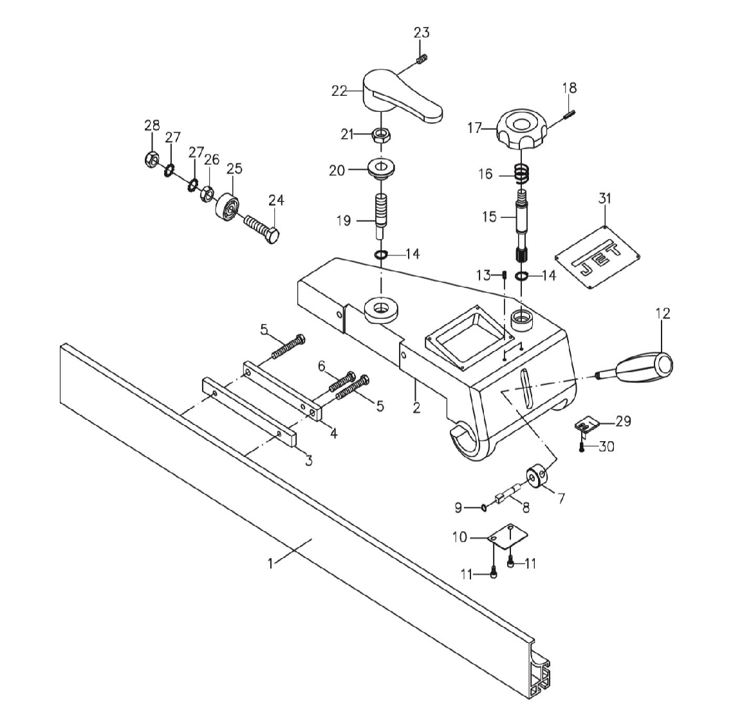

Parts List For The JTSS-3200X Panel Saw
Rip Fence Assembly

17

Rip Fence Assembly
Index Part
No. No. Description Size Qty.
1 JTSS1500-501 Rip Fence Profile 1
2 JTSS3200X-502 Smooth Base 1
3 JTSS1500-502 Lock Block (Short) 1
4 JTSS1500-503 Lock Block (Long) 1
5 TS-1490101 Hex Cap Bolt M8x55 2
6 TS-1490071 Hex Cap Bolt M8x40 1
7 JTSS1500-508 Eccentric Wheel 1
8 JTSS1500-504 Eccentric Arbor 1
9 JTSS1500-509 Ring STW-8 1
10 JTSS1500-505 Push Board 1
11 JTSS1500-507 Round Head Screw M5x8 2
12 JTSS1500-519 Rubber Handle 1
13 TS-1522031 Set Screw M5x10 2
14 JTSS1500-510 Ring STW-16 2
15 JTSS3200X-515 Gear Arbor 1
16 JTSS1500-516 Spring 1
17 JTSS1500-532 Knob 1
18 JTSS1500-531 Spring Pin Ø4x25 1
19 JTSS1500-522 Eccentric 1
20 JTSS1500-521 Bushing 1
21 TS-154010 Hex Nut M16x2.0P 1
22 JTSS1500-520 Handle 1
23 TS-1523061 Set Screw M6x20 1
24 TS-1492051 Hex Cap Bolt M12x50 1
25 JTSS1500-526 Wheel 1
26 JTSS1500-527 Hex Nut M12x1.25P 1
27 JTSS1500-528 Star Washer ø 12 2
28 JTSS1500-529 Lock Nut M12x1.25P 1
29 JTSS1500-512 Indicator 1
30 TS-2284081 Pan Head Screw M4x10 2
31 JTSS1500-506 Label 1
............ JTSS1500-RFA Rip Fence Assembly (2-32)

18
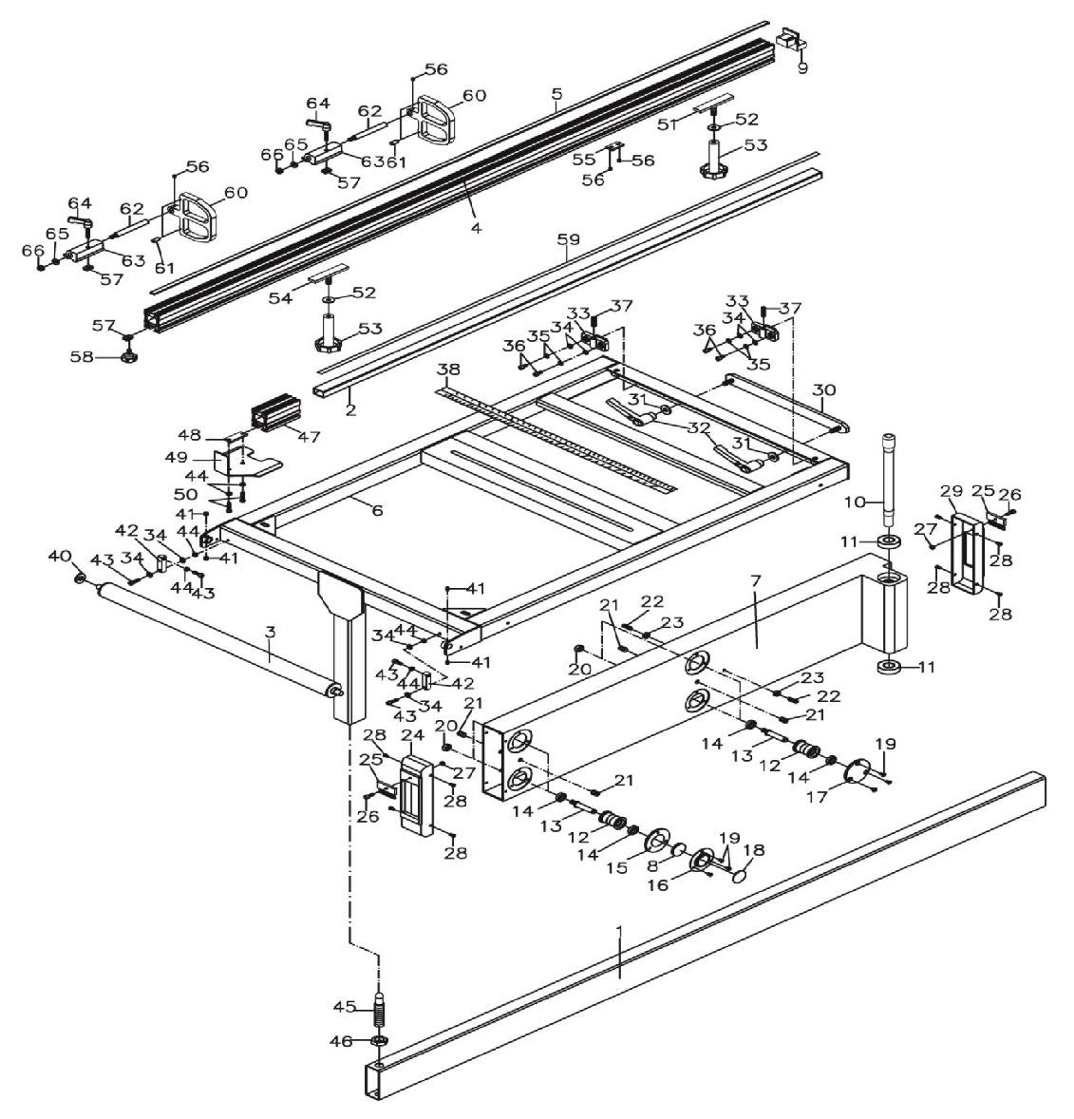

Parts List For The JTSS-3200 Panel Saw
Cross Cut Table Assembly

19

Cross Cut Table Assembly

Index Part
No. No. Description Size Qty.

1 JTSS3000-301 Extension Sliding 1
2 JTSS3000-351 Scale Tube 1
3 JTSS3000-339 Work Table Roller Assembly 1
4 JTSS3000-355 Cross Cut Fence 1
5 JTSS3000-360 Scale 1
6 JTSS3000-336 Cross Cut Table 1
7 JTSS3200X-807 Support Arm 1
8 JTSS3000-308 Magnet 2
9 JTSS3000-356 End Plug for Cross Cut Fence 1
10 JTSS3200X-810 Arm Arbor 1
11 BB-6204ZZ Ball Bearing 6204ZZ 2
12 JTSS3200X-812 Eccentric Wheel 4
13 JTSS3000-318 Eccentric Arbor 4
14 JTSS3000-307 Ball Bearing 6901ZZ 4
15 JTSS3000-305 Rotate Arbor Support 2
16 JTSS3000-309 Magnet Base 2
17 JTSS3200X-817 Rotate Arbor Support 2
18 JTSS3200X-817 Protector 4
19 JTSS3000-310 Flat Head Screw M5x8 12
20 TS-2311101 Hex Nut M10 4
21 JTSS3000-319 Nylon Set Screw M12x12 4
22 TS-1524051 Socket Set Screw M8x20 2
23 TS-2311081 Hex Nut M8 2
24 JTSS3000-322 Sliding Arm Cover-Front 1
25 JTSS3000-320 Brush 2
26 TS-1502041 Socket Head Cap Screw M5x15 2
27 TS-1540031 Hex Nut M5 2
28 JTSS3000-313 Flat Head Screw M5x8 8
29 JTSS3000-314 Sliding Arm Cover 1
30 JTSS3000-331 Lock Board 1
31 TS-1550071 Flat Washer M10 2
32 JTSS3000-326 Adjust Lever 2
33 JTSS3000-333 Support Adjustment Block 2
34 TS-1550041 Flat Washer M6 4
35 TS-2361061 Lock Washer M6 4
36 TS-1503031 Socket Head Cap Screw M6x12 4
37 TS-1524061 Set Screw M8x30 2
38 JTSS3000-335 Angle Label 1
40 TS-2360121 Flat Washer M12 2
41 TS-1523011 Socket Set Screw M6x6 4
42 JTSS3000-330 Stop Block 2
43 TS-1503061 Socket Head Cap Screw M6x25 4
44 TS-1540041 Hex Nut M6 6
45 JTSS3000-303 Sliding Arm Arbor 1
46 JTSS3000-302 Hex Nut M20xP2.5 1
47 JTSS3000-341 Cross Cut Fence 1
48 JTSS3000-342 Fix Plate 1
49 JTSS3000-344 Cover Plate 1
50 JTSS3000-343 Round Head Screw M6x25 2
51 JTSS3000-350 Fix Block 1

20

Index Part
No. No. Description Size Qty.

52 TS-1550071 Flat Washer M10 2
53 JTSS3000-349 Knob M10x90 2
54 JTSS3200X-851 Fix Block 1
55 JTSS3000-354 Fix Block 1
56 TS-1523011 Socket Set Screw M6x6 4
57 JTSS3000-348 Set Nut 3
58 JTSS3000-346 JET Knob M6x35 1
59 JTSS3000-340 Scale 1
60 JTSS3000-365 Clamping 2
61 JTSS3000-364 Clamping Rubber Pad 4
62 JTSS3000-357 Clamping Shaft 2
63 JTSS3000-361 Clamping Bracket 2
64 JTSS3000-363 Adjust Lever M6x35 2
65 TS-1550061 Flat Washer M8 2
66 TS-1540031 Lock Nut M8 2
............ JTSS3000-570 Crosscut Stop Assembly (56,57,60-66) 1

21
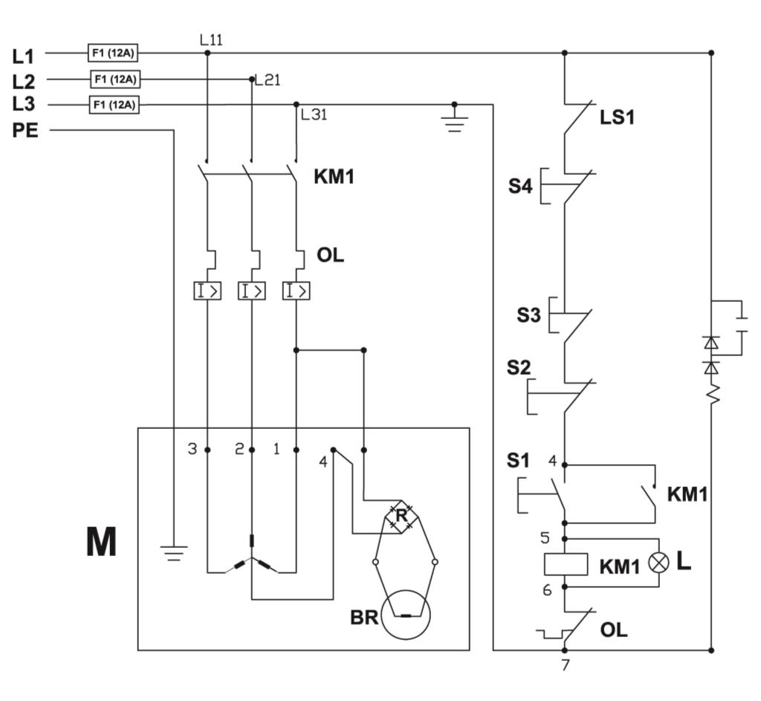

JTSS-3200X-T…10000047XT…3~400V, 50Hz

colour of strands Litzenfarben couleur des cordons

BK black schwarz noir

BU blue blau bleu

BN brown braun brun

RD Red rot rouge

GY grey grau gris

GNYE green-yellow grü n-gelb vert-jaune

meaning of symbol Bedeutung der Zeichen interprétation

M main motor Hauptmotor moteur principal
S4 emergency stop switch Not-Aus Schalter arrêt d'urgence
S3 emergency stop switch Not-Aus Schalter arrêt d'urgence
S2 off switch Aus-Schalter bouton arrêt
S1 start switch Ein-Schalter bouton marche
KM1 contactor for main motor Hauptschü tz contacteur moteur
F fuse Sicherung fusible
BR Bridge rectifier Brü ckengleichrichter rectifier
TR transformer Transformator transformateur
LS limit switch Positionsendschalter micro
L lamp Maschinenleuchte lampe

22

